|  |  |
| --- | --- |
| **Name:** | MANSI UNIYAL |
| **Roll Number:** | 19EE10039 |

**Experiment No. 9**

**Name of the Experiment: Zener Diode-Voltage Regulator**

1. **Aim of the experiment**
2. Explain the function of a Zener diode
3. Explain Zener Diode as Voltage Regulator
4. **Tools used:**
5. Zener diode
6. Resistor
7. Rheostat
8. Voltmeter
9. Ammeter
10. DC source
11. Bread board
12. Stimulation: Vlabs
13. **Background knowledge (brief):**
14. Zener Diode
    1. Special kind of diode. Permits current to flow in the forward direction as normal, but will also allow it to flow in the reverse direction when the voltage is above the breakdown voltage or ‘Zener’ voltage. 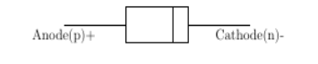

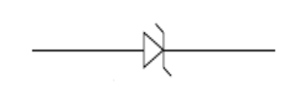

1. Function of Zener Diode
   1. The Zener voltage is high, and the diode is permanently damaged if a reverse current above that value is allowed to pass through it.
   2. In the reverse bias direction, there is practically no reverse current flow until the breakdown voltage is reached. When this occurs, there is a sharp increase in reverse current. Varying amount of reverse current can pass through the diode without damaging it. The breakdown voltage or Zener voltage (VZ) across the diode remains relatively constant.
2. Zener Diode as a Voltage Regulator
   1. Basically, there are two type of regulations such as:
      * 1. Line Regulation - In this type of regulation, series resistance and load resistance are fixed, only input voltage is changing. Output voltage remains the same as long as the input voltage is maintained above a minimum value.
        2. Load Regulation - In this type of regulation, input voltage is fixed and the load resistance is varying. Output volt remains same, as long as the load resistance is maintained above a minimum value.
3. Line Regulation

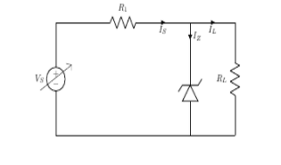

In Line Regulation, Load resistance is constant and input voltage varies. VI must be sufficiently large to turn the Zener Diode ON.



So, the minimum turn-on voltage VImin is



The maximum value of VI is limited by the maximum Zener current IZmax



IL is fixed at



So maximum VI is



or,



For VI<VZ,



For VI>VZ,



1. Load Regulation

In Load Regulation, input voltage is constant and Load resistance varies. Too small a Load Resistance RL, will result in VTh<VZ and Zener Diode will be OFF.



So, the minimum load resistance RL



Any load resistance greater than RLmin will make Zener Diode ON



RLmin will establish maximum IL as



Vs is the voltage drop across RS





For RL < RLmin,



For RL > RLmin,



1. **Circuit (hand drawn/image)**

1)Zener Diode - Line Regulation 2) Zener Diode - Load Regulation

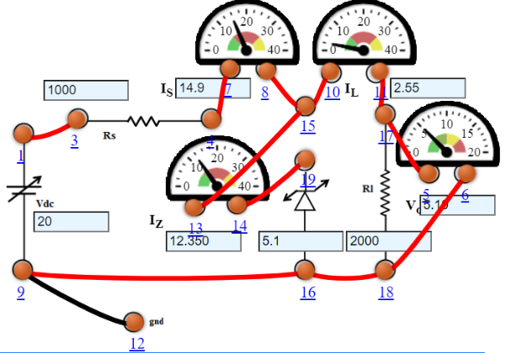 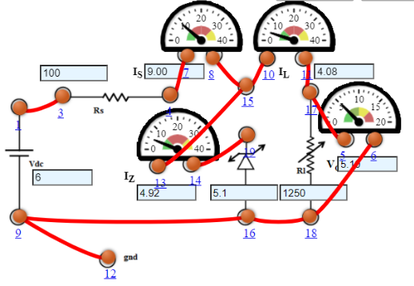

3)Zener Characteristics

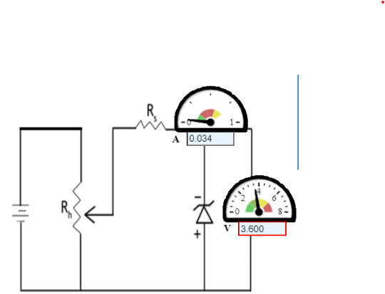

1. **Measurement Data (Tabular form)**

1)Zener Diode - Line Regulation 2) Zener Diode - Load Regulation

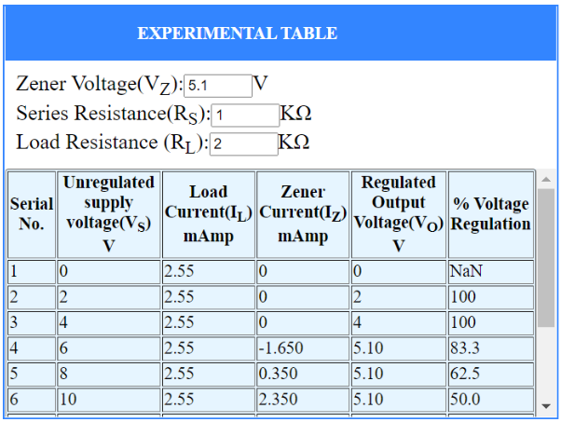 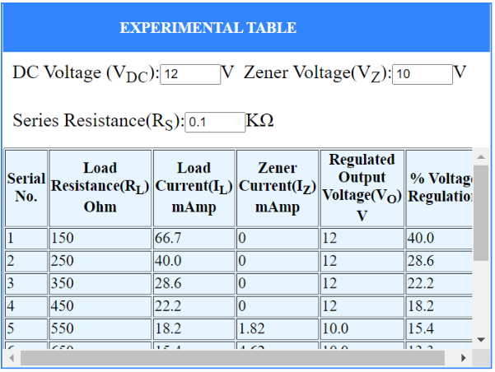

3)Zener Characteristics

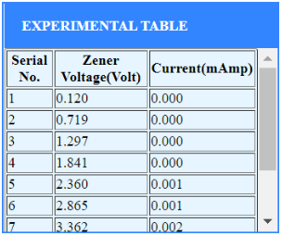

1. **Graph (Image)/Screenshots**

Zener Diode - Line Regulation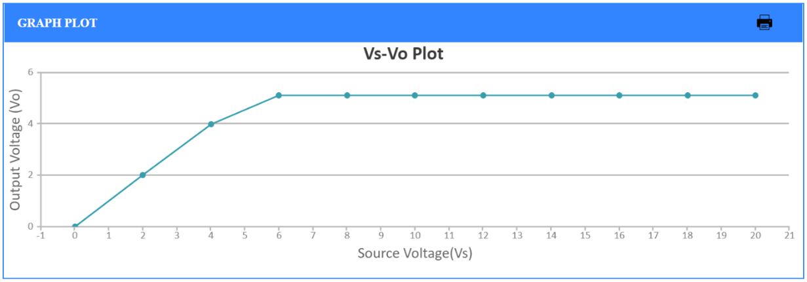

Zener Diode - Load Regulation

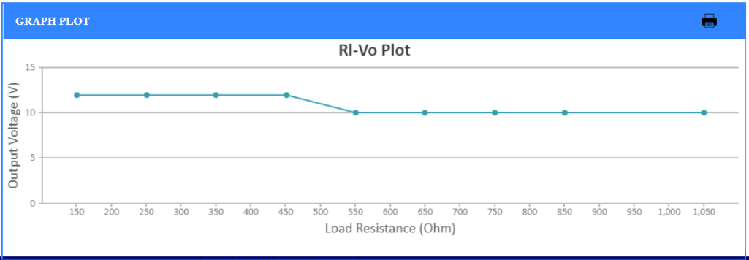

Zener Characteristics IN4733A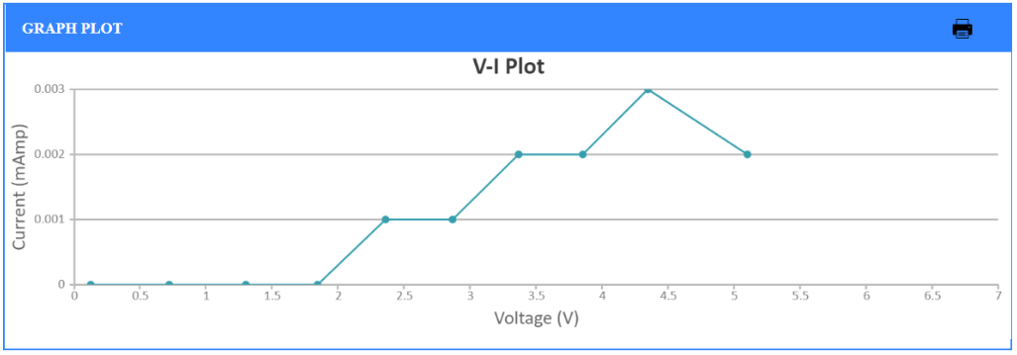

Zener Characteristics IN4739A

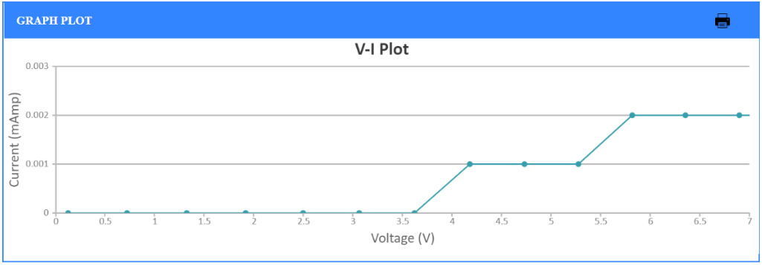

Zener Characteristics IN4729A

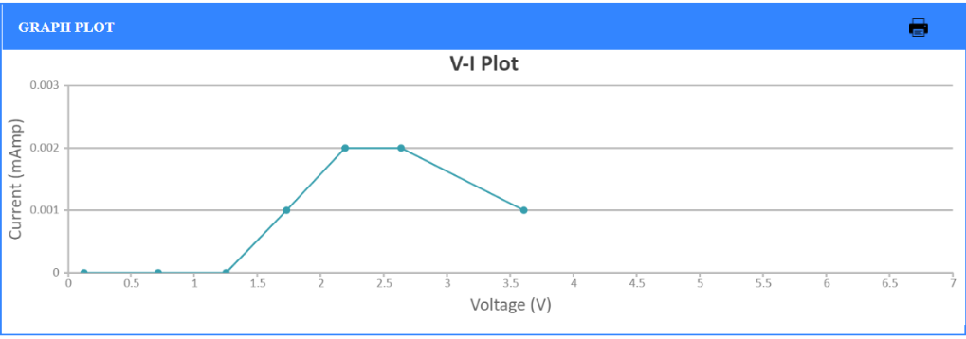

1. **Conclusion**

A Zener diode can be used as a voltage regulator.

1. **Discussions**

Zener diodes are widely used as voltage references and as shunt regulators to regulate the voltage across small circuits. When connected in parallel with a variable voltage source so that it is reverse biased, a Zener diode conducts when the voltage reaches the diode's reverse breakdown voltage. From that point on, the low impedance of the diode keeps the voltage across the diode at that value.

1. **Quiz**

